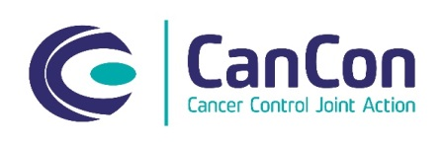
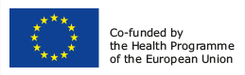

SCHEDA ISCRIZIONE

Symposium on
Improving cancer care through cancer networks: existing models in Italy and in Europe
22 Aprile 2016

Sala Pegaso, Palazzo Strozzi Sacrati,
Piazza Duomo, 10, Firenze

NOME e COGNOME _______________________________________________

CODICE FISCALE__________________________________________________

RESIDENZA______________________________________________________

DOMICILIO ( se diverso da residenza)_________________________________
_______________________________________________________________

Tel________________________E-Mail_______________________________

ENTE DI APPARTENENZA __________________________________________

SEDE LAVORATIVA E INDIRIZZO _____________________________________
______________________________________________________________

Data, Firma

Da inviare a info@adhoc-eventi.it o fax +39 055 4480891

